The 8th Sunday after Trinity
Sunday 2nd August 2020
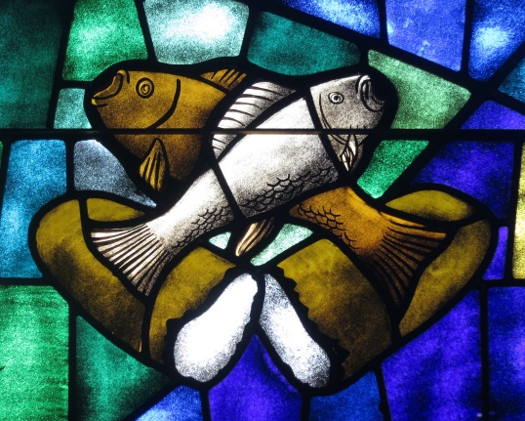

The Collect for 8th Sunday after Trinity
Almighty Lord and everlasting God,
we beseech you to direct, sanctify and govern
both our hearts and bodies
in the ways of your laws
and the works of your commandments;
that through your most mighty protection, both here and ever,
we may be preserved in body and soul;
through our Lord and Saviour Jesus Christ,
who is alive and reigns with you,
in the unity of the Holy Spirit,
one God, now and for ever. Amen

Romans 9:1-5
I am speaking the truth in Christ—I am not lying; my conscience confirms it by the Holy Spirit— I have great sorrow and unceasing anguish in my heart. For I could wish that I myself were accursed and cut off from Christ for the sake of my own people, my kindred according to the flesh. They are Israelites, and to them belong the adoption, the glory, the covenants, the giving of the law, the worship, and the promises; to them belong the patriarchs, and from them, according to the flesh, comes the Messiah, who is over all, God blessed forever. Amen.

The Gospel Reading: Matthew 14:13-21
Now when Jesus heard this, he withdrew from there in a boat to a deserted place by himself. But when the crowds heard it, they followed him on foot from the towns. ¹⁴When he went ashore, he saw a great crowd; and he had compassion for them and cured their sick. ¹⁵When it was evening, the disciples came to him and said, ‘This is a deserted place, and the hour is now late; send the crowds away so that they may go into the villages and buy food for themselves.’ ¹⁶Jesus said to them, ‘They need not go away; you give them something to eat.’ ¹⁷They replied, ‘We have nothing here but five loaves and two fish.’ ¹⁸And he said, ‘Bring them here to me.’ ¹⁹Then he ordered the crowds to sit down on the grass. Taking the five loaves and the two fish, he looked up to heaven, and blessed and broke the loaves, and gave them to the disciples, and the disciples gave them to the crowds. ²⁰And all ate and were filled; and they took up what was left over of the broken pieces, twelve baskets full. ²¹And those who ate were about five thousand men, besides women and children.

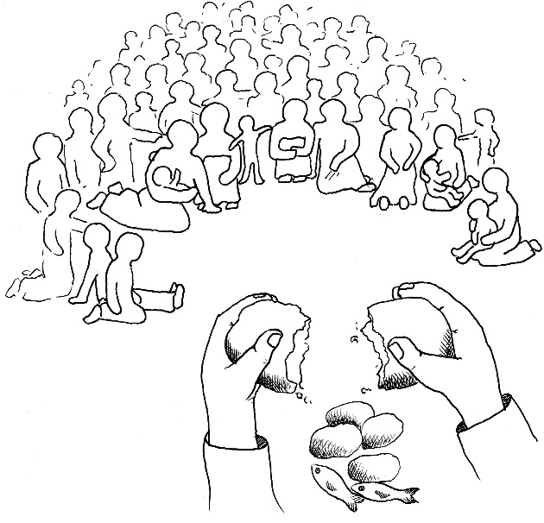

Reflection from Revd Helen:

Today’s gospel reading of the miraculous feeding of the 5,000 is one of the best known miracles of Jesus. It is in fact the only one recorded in all four gospels. We often refer to it as “feeding the 5,000” but the gospel records that in addition to 5,000 men there were women and children, so it was in fact a vast crowd.

We are told at the start of this reading that Jesus has tried to escape from the crowds for some peace and quiet. It’s not surprising that Jesus wants to be alone, because the news that he has just received is that his cousin John the Baptist has been beheaded by Herod. But the crowds persist in following Jesus, and when Jesus sees them He has compassion for them. He cures their sick, and before they take the long road home, he takes five loaves and two fish, he blesses and breaks the loaves and gives them to the disciples and the disciples give them to the crowds. And all eat and are abundantly filled.

If the disciples had had their way, they would have sent the crowd packing. ‘It’s late and we’re in a deserted place’, they say to Jesus. ‘Send the crowds away so that can go and find something to eat themselves’. You can understand where they’re coming from. And when Jesus disagrees with them, the disciples still look at this through human eyes – ‘we can’t feed this lot ourselves’. The task before them is so overwhelming that they feel helpless to even begin to tackle it. How do you feed a football crowd with a picnic lunch? Again the disciples see only the human resources available to them. But with what they had, Jesus worked a miracle.

When we reflect on this miracle, it can prompt us to consider whether we become daunted or discouraged by the magnitude of some of the tasks and hurdles that face us. Do we look at things only through human eyes rather than God’s eyes? Do we see the challenges before us as giants and ourselves as grasshoppers? Often we trust in our own strength alone and our human resources, rather than trust in Jesus and the power of God that is available to us. What can seem little in our hands is much in God’s. By that lakeside in Galilee, Jesus worked through the disciples’ hands. Today he works through ours. Whatever we can offer - however little - he can use. He can take what we might regard as pitifully inadequate resources and multiply them over and over again.

St Paul writes to the church at Ephesus of “him who by the power at work within us is able to accomplish abundantly far more than all we can ask or imagine” (Ephesians 3:20). I love that verse! Our God is a powerful God of creative abundance. He blesses generously, but sometimes we just don’t see it, and we underestimate the power He makes available to us.

So, may our eyes be opened to see the gifts of grace that He has placed in our hands. May we have the faith to offer these gifts to Him in service, trusting that He will bless and multiply them, so that by His power at work within us, we might give blessing to others and glory to Him. Amen.

With greetings to you all from
The Rector and Revd Helen

Common Worship: Services and Prayers for the Church of England, material from which is included here, is copyright © The Archbishops' Council 2000 and published by Church House Publishing. Bible readings are taken from the New Revised Standard Version

