The 13th Sunday after Trinity
Sunday 6th September 2020
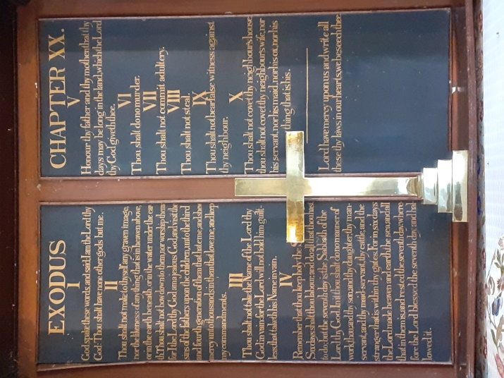
The Collect for 13th Sunday after Trinity
Almighty God,
who called your Church to bear witness
that you were in Christ reconciling the world to yourself:
help us to proclaim the good news of your love,
that all who hear it may be drawn to you;
through him who was lifted up on the cross,
and reigns with you in the unity of the Holy Spirit,
one God, now and for ever.
Amen.

Romans 13: 8 - end
Owe no one anything, except to love one another; for the one who loves another has fulfilled the law. ⁹The commandments, ‘You shall not commit adultery; You shall not murder; You shall not steal; You shall not covet’; and any other commandment, are summed up in this word, ‘Love your neighbour as yourself.’ ¹⁰Love does no wrong to a neighbour; therefore, love is the fulfilling of the law.
11 Besides this, you know what time it is, how it is now the moment for you to wake from sleep. For salvation is nearer to us now than when we became believers; ¹²the night is far gone, the day is near. Let us then lay aside the works of darkness and put on the armour of light; ¹³let us live honourably as in the day, not in revelling and drunkenness, not in debauchery and licentiousness, not in quarrelling and jealousy. ¹⁴Instead, put on the Lord Jesus Christ, and make no provision for the flesh, to gratify its desires.
The Gospel Reading: Matthew 18: 15-20
‘If another member of the church sins against you, go and point out the fault when the two of you are alone. If the member listens to you, you have regained that one. ¹⁶But if you are not listened to, take one or two others along with you, so that every word may be confirmed by the evidence of two or three witnesses. ¹⁷If the member refuses to listen to them, tell it to the church; and if the offender refuses to listen even to the church, let such a one be to you as a Gentile and a tax-collector. ¹⁸Truly I tell you, whatever you bind on earth will be bound in heaven, and whatever you loose on earth will be loosed in heaven. ¹⁹Again, truly I tell you, if two of you agree on earth about anything you ask, it will be done for you by my Father in heaven. ²⁰For where two or three are gathered in my name, I am there among them.’

Reflection from the Rector:
Have you ever bought a book and turned to the closing words of the final chapter just to see how it all works out in the end. I certainly have and make a conscious decision sometimes not to do that and start where one is meant to, which is at the beginning! This mornings gospel is slightly different for me in that verse 20 helps me makes sense of the preceding verses. “ Where two or three are gathered together in my name. I am among them”. We are of Christ and about his business- a great joy and privilege but also bearing much personal responsibility to each other as individuals and also corporately.
Where two or three……………………..
The Gospel reading for this Sunday is part of a chapter that is concerned with church order and so is about the household of faith and the need for the community to be at one in Christ. No easy task as we are all very different people but important in that we need be a people who whilst airing differences nevertheless have a way of being able to find common ground in order that unity is maintained and witness to the wider world unimpaired . How do we react when someone goes astray-well advice is given. What matters most is that action is taken in love. Within the wider Christian Community the ecumenical movement is an important statement to the search to understand, for tolerance and a desire to learn from another tradition and a shared desire to see the big picture rather than close down to the smaller and the insular . This is something that can be applied within denominations.
Where two or three……………………
Biblical scholars have long debated about this whole section of Chapter 18 of Matthews Gospel in that certain bits seem to have been added and could not have been said by Jesus himself in that there is a reference to “ the church” but that did not exist at the time , and it implies a fully developed and organised church with a system of church discipline-it also speaks of tax collectors and sinners as being total outcasts and yet we know that Jesus befriended them and never spoke of them as being hopeless outsiders.. There is however a very important theme that runs throughout this passage and that has to do with moving on in life but putting things right rather than glossing over them. One of the ideas behind the sharing of the peace is that all is put right before receiving of the sacrament.
Where two or three………………………………………….
Christian community must be a blue print for how wider society should conduct itself . What is being said in this Gospel reading is that we must never tolerate a situation in which there is a breach of personal relationships that is not attended to and put right in every way possible.
The Epistle for today picks up this same theme in its opening words” Owe no one anything , except to love one another, for the one who loves another has fulfilled the law”. Loving means wanting the best for another .Loving means that we look to the good of others before our own wishes, loving means tolerance and forgiveness and understanding that reaches out beyond coping to real empathy that in itself leads to restored relationships and new action. Loving means that we ask for forgiveness for ourselves and give it to others and it is in this that we are told that we fulfil the law in loving God and our neigbours as ourselves.
Finally , I go back to the beginning and Jesus words to us “ where two or three are gathered together” ……..there is tremendous encouragement in this passage in our living of the Christian life in community-much to give thanks for in the opportunities that we all have to build each other up in the faith and to learn from each other and so grow together in Christ. All find a welcome here which is the hallmark of authentic Christian community, it is a real joy to come in here as I did just the other day and meet visitors and be able to speak of what the beauty and peace of this holy place is really about – a living place in which we can grow in Christ -to which the worshippers of the many centuries have given witness and of who we are both the inheritors and present day members. This sacrament confirms our unity and in the strength of the Lord who continually gives himself for us we go out to live faithful Christ centred lives which is an offering we can give to the fractured and broken world that Christ came to save and to which we minister in His Name and for the extension of His Kingdom. Amen.

With greetings to you all from
The Rector and Revd Helen

Common Worship: Services and Prayers for the Church of England, material from which is included here, is copyright © The Archbishops' Council 2000 and published by Church House Publishing. Bible readings are taken from the New Revised Standard Version

