The 14th Sunday after Trinity
Sunday 13th September 2020
Battle of Britain Sunday
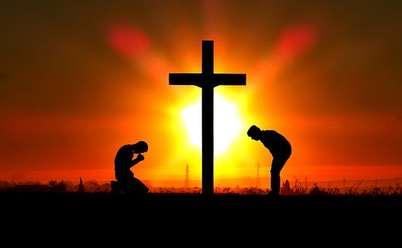

The Collect for 14th Sunday after Trinity
Almighty God,
whose only Son has opened for us
a new and living way into your presence:
give us pure hearts and steadfast wills
to worship you in spirit and in truth;
through Jesus Christ your Son our Lord,
who is alive and reigns with you,
in the unity of the Holy Spirit,
one God, now and for ever.
Amen.

Romans 14: 1- 12
Welcome those who are weak in faith, but not for the purpose of quarrelling over opinions. ²Some believe in eating anything, while the weak eat only vegetables. ³Those who eat must not despise those who abstain, and those who abstain must not pass judgement on those who eat; for God has welcomed them. ⁴Who are you to pass judgement on servants of another? It is before their own lord that they stand or fall. And they will be upheld, for the Lord is able to make them stand.
5 Some judge one day to be better than another, while others judge all days to be alike. Let all be fully convinced in their own minds. ⁶Those who observe the day, observe it in honour of the Lord. Also those who eat, eat in honour of the Lord, since they give thanks to God; while those who abstain, abstain in honour of the Lord and give thanks to God.
7 We do not live to ourselves, and we do not die to ourselves. ⁸If we live, we live to the Lord, and if we die, we die to the Lord; so then, whether we live or whether we die, we are the Lord’s. ⁹For to this end Christ died and lived again, so that he might be Lord of both the dead and the living.
10 Why do you pass judgement on your brother or sister? Or you, why do you despise your brother or sister? For we will all stand before the judgement seat of God. ¹¹For it is written,
‘As I live, says the Lord, every knee shall bow to me,
and every tongue shall give praise to God.’
¹²So then, each of us will be accountable to God.
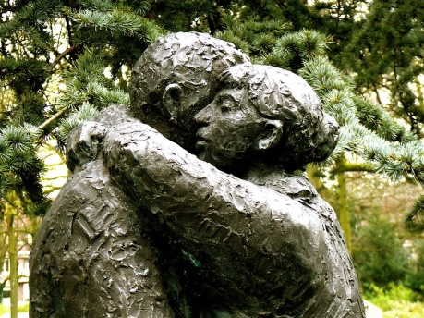

Gospel Reading John 15 v 9 to 17
As the Father has loved me, so I have loved you; abide in my love. If you keep my commandments, you will abide in my love, just as I have kept my Father’s commandments and abide in his love. I have said these things to you so that my joy may be in you, and that your joy may be complete.
‘This is my commandment, that you love one another as I have loved you. No one has greater love than this, to lay down one’s life for one’s friends. You are my friends if you do what I command you. I do not call you servants any longer, because the servant does not know what the master is doing; but I have called you friends, because I have made known to you everything that I have heard from my Father. You did not choose me but I chose you. And I appointed you to go and bear fruit, fruit that will last, so that the Father will give you whatever you ask him in my name. I am giving you these commands so that you may love one another.

Reflection from the Rector:

Remembering those who gave their all for us
This year we are commemorating the 80th Anniversary of what became known as The Battle of Britain. From the 10th July to the 31st October 1940 a terrible battle ranged in the skies that was part of our answer to Nazi Germany’s reign of terror that was extending over so much of Europe and that threatened to engulf our island home as well. Many played their part in the construction of the aircraft needed, as Air Raid Wardens, Firefighters and members of The Home Guard and well as all the personnel needed on the stations many working long hours that the aircraft be ready to return to the skies and carry on the struggle. As the waves of enemy aircraft darkened the skies they met the might and power of The Royal Airforce who turned the tide of the war in Europe. We started with only 1963 aircraft as opposed to 2250 of the enemy and yet we won through. Churchill was to put it like this "The gratitude of every home in our Island, in our Empire, and indeed throughout the world, except in the abodes of the guilty, goes out to the British airmen who, undaunted by odds, unwearied in their constant challenge and mortal danger, are turning the tide of the World War by their prowess and by their devotion. Never in the field of human conflict was so much owed by so many to so few."
Air personnel from so many countries took part including Poland ,New Zealand, Australia, Canada, Czechoslovakia, Belgium, France, The USA and South Africa. Losses on both sides in the Battle were terrible including some 14,286 civilians killed and over 20,000 wounded.
These many years on we salute those who gave their all that we might know once again the freedom that peace brings. We shall ever be in their debt. Whenever I go to Blacon Cemetery in Chester I visit the War Graves Commission Cemetery there and pause and reflect on two things, firstly ,on the tragedy of lives that had only just begun cut short . They were so young ,so brave-their names live on today and will never be forgotten.
Secondly I think of the dreams and hopes and plans cut short in the cruelty of war-what of the loved ones and families and all the life ahead of them.
On this Battle of Britain Sunday part of remembering is summed up for me in the words “ When you go home tell them of us and say for your tomorrow we gave our today” We take up the fight with the same conviction and hope that sustained them in the darkness and horror that the dream and the hope of a lasting peace is turned into a reality. A certain Harry S Addison once wrote “that the world must be a place of happy homes and laughing children, a world from which fear has been lifted like the smoke pall from an industrial city, a world in which we shall look for care worn faces and find none. A world in which parents need not fear that their children will be killed in the next war. A world of lasting peace in heart and home and between nations- a peace that will not be alone the absence of war but the liberation of all our energies in to the creation of a world in which all have a part to play”.
Another part of remembering is contained in the words of our Gospel reading that of Jesus exhorting us to love one another as the Father loved him and he loves us. Let us daily take up that challenge and may it be a part of our tribute to those who laid down their lives and of our commitment to the continued struggle of good over evil. May God bless us in our endeavour that we may always be worthy of their sacrifice. Amen.

With greetings to you all from
The Rector and Revd Helen

Common Worship: Services and Prayers for the Church of England, material from which is included here, is copyright © The Archbishops' Council 2000 and published by Church House Publishing. Bible readings are taken from the New Revised Standard Version

