The 15th Sunday after Trinity
Sunday 20th September 2020

On Monday 21st September the Church celebrates the Festival of St Matthew, Apostle and Evangelist. We shall celebrate this in our readings and reflection for today.
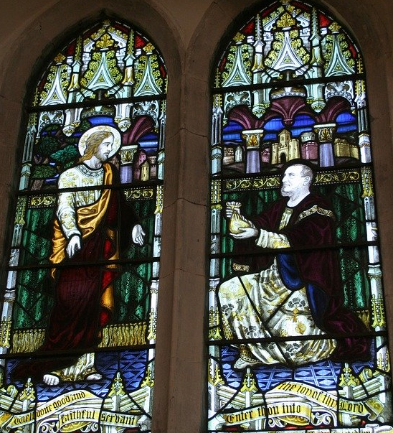
The Collect for 15th Sunday after Trinity
God, who in generous mercy sent the Holy Spirit
upon your Church in the burning fire of your love:
grant that your people may be fervent
in the fellowship of the gospel
that, always abiding in you,
they may be found steadfast in faith and active in service;
through Jesus Christ your Son our Lord,
who is alive and reigns with you,
in the unity of the Holy Spirit,
one God, now and for ever.

The Collect for Matthew, Apostle and Evangelist
O almighty God,
whose blessed Son called Matthew the tax collector
to be an apostle and evangelist:
give us grace to forsake the selfish pursuit of gain
and the possessive love of riches
that we may follow in the way of your Son Jesus Christ,
who is alive and reigns with you,
in the unity of the Holy Spirit,
one God, now and for ever.
Proverbs 3:13-18
¹³ Happy are those who find wisdom,
and those who get understanding,
¹⁴ for her income is better than silver,
and her revenue better than gold.
¹⁵ She is more precious than jewels,
and nothing you desire can compare with her.
¹⁶ Long life is in her right hand;
in her left hand are riches and honour.
¹⁷ Her ways are ways of pleasantness,
and all her paths are peace.
¹⁸ She is a tree of life to those who lay hold of her;
those who hold her fast are called happy.

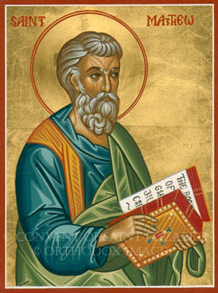

The Gospel Reading: Matthew 9: 9-13
9 As Jesus was walking along, he saw a man called Matthew sitting at the tax booth; and he said to him, ‘Follow me.’ And he got up and followed him.
10 And as he sat at dinner in the house, many tax-collectors and sinners came and were sitting with him and his disciples. ¹¹When the Pharisees saw this, they said to his disciples, ‘Why does your teacher eat with tax-collectors and sinners?’ ¹²But when he heard this, he said, ‘Those who are well have no need of a physician, but those who are sick. ¹³Go and learn what this means, “I desire mercy, not sacrifice.” For I have come to call not the righteous but sinners.’

Reflection from Revd Helen:
Matthew’s call to follow Jesus is all the more remarkable because Matthew was a tax collector. It is difficult to convey the distrust hidden in the description “tax collector”. The tax collectors of Jesus’ day were despised because they were collecting taxes on behalf of the Romans, an alien occupying power. Their work could easily lead to corruption and extortion as they made the best profit they could for themselves. They would not only fleece their fellow countrymen but also swindle the government by taking bribes from rich people who wanted to evade their taxes. It is easy to see how tax collectors acquired a reputation for being dishonest official crooks; they were banned from synagogues and were numbered among ‘sinners’ by the righteous Jews of the time.

Matthew was sitting at his tax booth on what was just an ordinary day in the life of a tax collector when Jesus calls to him - directly and unexpectedly - “Follow me”. Matthew responds at once and as a result his life is utterly transformed. This social pariah becomes an Apostle of Christ, a Leader in the church and a writer of one of the Gospels.

We read how Matthew celebrates this calling with a dinner party where the guests number “many tax collectors and sinners” along with Jesus and the disciples. To a 1st century Jew, dining with someone was a significant act– it meant acceptance and fellowship. And here is Jesus partying with those who were rejected and ostracised by the religious establishment. The Pharisees are outraged and vent their hostility upon the disciples. “Why does your teacher eat with tax collectors and sinners?” they ask. It is this question that gives Jesus the opening for one of his greatest sayings. “Those who are well have no need for a physician, but those who are sick……I have come to call not the righteous but sinners”. Jesus is not saying here that some people are so good that they had no need of anything he could give, or that he was not interested in people who were good. He is saying that he came to invite people who are conscious of their sin and aware of their need for a saviour, that only those who know how much they need him can accept his invitation. The Pharisees’ problem was that they were so self-satisfied that in their pride and self-righteousness they failed to see that they needed healing.

I think that the Pharisees’ problem can also be a problem for us today in that we may lack any real sense of our own sinfulness. We may think we are morally and spiritually healthy such that God can do nothing for us. I have conversations with folk who think that Christians are ‘good people who go to church’. That Christianity is only for nice, good people is a popular myth. The reality is that Christians are sinners who know their need and know where to find the remedy. St Paul writes in Romans 3:23, “There is no distinction, since all have sinned and fall short of the glory of God”. But Paul continues with the truth that we “are now justified by his grace as a gift, through the redemption that is in Christ Jesus”. We may find it rather offensive to be described as a sinner when we are good, decent, law-abiding folk, but by God’s standards we are sinners! As one commentator puts it, “in God’s eyes, whether we like it or not, we are not good or bad people, but forgiven or unforgiven bad people”. Unlike other world religions which have us clambering up ladders striving for our God to accept us, Christianity is the opposite. God sent his Son to us to find us just as we are and offer us forgiveness and a new start. On the Cross Jesus paid the price of every sin he would ever forgive.

I believe we can learn much from the calling of Matthew. This account is somewhat unsettling because it serves as a warning. It warns us to avoid self –righteousness, and to recognise our own need for God’s forgiveness. It warns us to expect to find Jesus in places and in people we may least expect.

But it also brings hope. It brings hope for those who want to follow Jesus but don’t feel good enough, because like Matthew when we answer Jesus’ call then the good news of the gospel means forgiveness, unconditional acceptance and a fresh start. And it brings hope to each and every one of us because in the calling of Matthew we see Jesus’ power to see in us not only the person we were and are, but also the person we can become when we follow Him. Amen

With greetings to you all from
The Rector and Revd Helen

Common Worship: Services and Prayers for the Church of England, material from which is included here, is copyright © The Archbishops' Council 2000 and published by Church House Publishing. Bible readings are taken from the New Revised Standard Version

