The 16th Sunday after Trinity
Sunday 27th September 2020

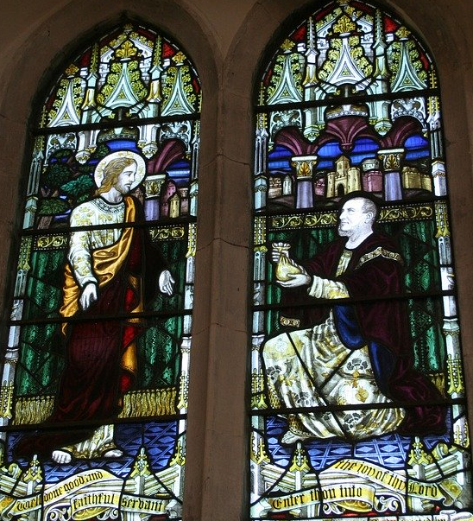
The Collect for 16th Sunday after Trinity
Lord of creation,
whose glory is around and within us:
open our eyes to your wonders
that we may serve you with reverence
and know your peace at our lives’ end
through Jesus Christ our Lord. Amen.

The Epistle Philippians 2 v 1 to 13
If then there is any encouragement in Christ, any consolation from love, any sharing in the Spirit, any compassion and sympathy, make my joy complete: be of the same mind, having the same love, being in full accord and of one mind. Do nothing from selfish ambition or conceit, but in humility regard others as better than yourselves. Let each of you look not to your own interests, but to the interests of others. Let the same mind be in you that was in Christ Jesus,
who, though he was in the form of God,
did not regard equality with God
as something to be exploited,
but emptied himself,
taking the form of a slave,
being born in human likeness.
And being found in human form,
he humbled himself
and became obedient to the point of death—
even death on a cross.
Therefore God also highly exalted him
and gave him the name
that is above every name,
so that at the name of Jesus
every knee should bend,
in heaven and on earth and under the earth,
and every tongue should confess
that Jesus Christ is Lord,
to the glory of God the Father.
Therefore, my beloved, just as you have always obeyed me, not only in my presence, but much more now in my absence, work out your own salvation with fear and trembling; for it is God who is at work in you, enabling you both to will and to work for his good pleasure.
Gospel John 6 v 35 -40
Jesus said to them, ‘I am the bread of life. Whoever comes to me will never be hungry, and whoever believes in me will never be thirsty. But I said to you that you have seen me and yet do not believe. Everything that the Father gives me will come to me, and anyone who comes to me I will never drive away; for I have come down from heaven, not to do my own will, but the will of him who sent me. And this is the will of him who sent me, that I should lose nothing of all that he has given me, but raise it up on the last day. This is indeed the will of my Father, that all who see the Son and believe in him may have eternal life; and I will raise them up on the last day.’

Refection from The Rector

He would eats this bread lives forever

The Gospel reading leads us to a celebration of the Eucharist as the central Act of Christian worship and we follow our Lords own command every time we do this together .

I remember the introduction of the Parish Communion movement in the Church of England. I was young and in the choir at my home church. We had quite a large sanctuary and The Altar was moved forward and the principal service on Sunday mornings became The Parish Communion Service and at 9 30am. There was still Matins at 11 and an early Celebration at 8 but it was to the 9 30am that most people seemed to go. In those far off days I could echo the later words of The Late Archbishop Robert Runcie who said that in his formative years he went along to St Faiths Great Crosby, Liverpool, where he was an Altar Server, without having any worked out and clear thought about the Communion Service other than he knew that he was taking part in something special. The choir was required at Evensong each week and I went to that as well but like Lord Runcie I felt something happened for me in the Eucharist week by week and I now know that it was the beginning of a journey that will take me to the heavenly banquet where I can feast in the nearer presence of my Lord and Saviour for ever.

The Gospel reading takes us back to the Last Supper and to the words of Institution .Take eat, this is my body which is given for you, do this in remembrance of me, and in the same way after supper he took the cup and having given thanks he said drink this all of you this is the blood of the new covenant which is shed for you and for many for the forgiveness of sins, do this as often as you drink it in remembrance of me. Body broken and blood shed and for you and for me. All our sins taken to the cross and in the wonder of that sacrifice washed away in the cleansing tide in that death that was no end but a new beginning not only for him but for his people ever since.

It is in our Baptism that we are made one with Christ and sharing in the Eucharist is how we grow.

Jesus had eaten with the little inner band throughout the course of his ministry but now he called his disciples to eat with him as he faced the greatest trail of his earthly ministry and so he asked that a room be prepared where they could assemble and eat together. Gathering and eating and sharing are basic needs in life and just as we are fed and feel included at the table of our earthly family and friends, so Jesus invites us, as he did those first disciples, to eat with him as we gather .

Jesus took the ordinary and everyday things of bread and wine and offered them to his Father in the words we now use 2000 years later and in that simple act of offering made the offering of himself as he told them that whenever they did this in the future they would do it in remembrance of him, that is until when in heaven we shall see him face to face and sit at his table in his presence. What a feast that will be and it is in that knowledge that we know that we are joined for ever to those who have gone before us in the realms of the eternity that is of this world and also that which is to come. The Eucharist is the meeting point between heaven and earth. I feel closest to those who have gone before me in this sacrament more than any other.

This then is the food that nourishes as the Gospel reading has it and so it is our staple diet . Jesus said I am the bread of life he also said he who eats my flesh and drinks my blood has eternal life. No physical change of substance here but a change by intention of purpose and so the action of the priest is that of the whole people of God and so we approach the sacrament with thankful hearts open to his gift to us to which the inner response to our Lord and Saviour can only be thank you as we journey on and adventure in His name.

With greetings to you all from
The Rector and Revd Helen

Common Worship: Services and Prayers for the Church of England, material from which is included here, is copyright © The Archbishops' Council 2000 and published by Church House Publishing. Bible readings are taken from the New Revised Standard Version

