All Saints Day 2020
Sunday 1st November

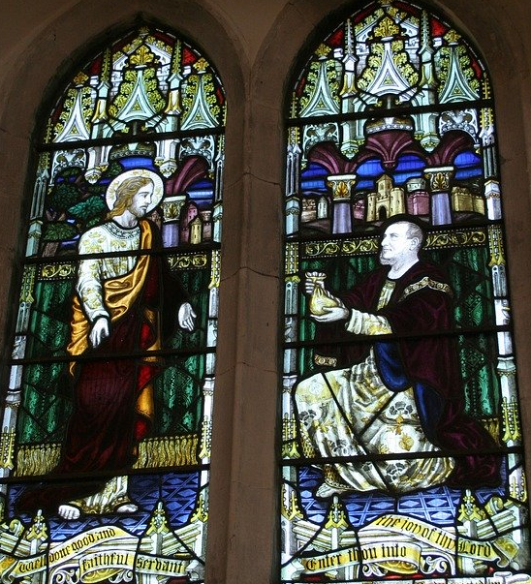
The Collect for All Saints Sunday
Almighty God, you have knit together your elect
in one communion and fellowship
in the mystical body of your Son Jesus Christ our Lord:
grant us grace so to follow your blessed saints
in all virtuous and godly living
that we may come to those inexpressible joys
that you have prepared for those who truly love you
through Jesus Christ your Son our Lord,
who is alive and reigns with you,
in the unity of the Holy Spirit,
one God now and for ever.

Epistle The Revelation to John Chapter 7 verses 9 to the end
After this I looked, and there was a great multitude that no one could count, from every nation, from all tribes and peoples and languages, standing before the throne and before the Lamb, robed in white, with palm branches in their hands. They cried out in a loud voice, saying,
‘Salvation belongs to our God who is seated on the throne, and to the Lamb!’
And all the angels stood around the throne and around the elders and the four living creatures, and they fell on their faces before the throne and worshipped God, singing,
‘Amen! Blessing and glory and wisdom
and thanksgiving and honour
and power and might
be to our God for ever and ever! Amen.’
Then one of the elders addressed me, saying, ‘Who are these, robed in white, and where have they come from?’ I said to him, ‘Sir, you are the one that knows.’ Then he said to me, ‘These are they who have come out of the great ordeal; they have washed their robes and made them white in the blood of the Lamb.
For this reason they are before the throne of God,
and worship him day and night within his temple,
and the one who is seated on the throne will shelter them.
They will hunger no more, and thirst no more;
the sun will not strike them,
nor any scorching heat;
for the Lamb at the centre of the throne will be their shepherd,
and he will guide them to springs of the water of life,
and God will wipe away every tear from their eyes.’
The Gospel Reading: Matthew 5 verses 1 to 12
When Jesus saw the crowds, he went up the mountain; and after he sat down, his disciples came to him. Then he began to speak, and taught them, saying:
‘Blessed are the poor in spirit, for theirs is the kingdom of heaven.
‘Blessed are those who mourn, for they will be comforted.
‘Blessed are the meek, for they will inherit the earth.
‘Blessed are those who hunger and thirst for righteousness, for they will be filled.
‘Blessed are the merciful, for they will receive mercy.
‘Blessed are the pure in heart, for they will see God.
‘Blessed are the peacemakers, for they will be called children of God.
‘Blessed are those who are persecuted for righteousness’ sake, for theirs is the kingdom of heaven.
‘Blessed are you when people revile you and persecute you and utter all kinds of evil against you falsely on my account. Rejoice and be glad, for your reward is great in heaven, for in the same way they persecuted the prophets who were before you.

Reflection from The Rector
Blessed are they that know their need of God

All Saints Day and the Commemoration of All Souls on the 2nd November are celebrations of community-a reminder to those of us living in this world that we are a part of those who have gone before us in faith and to whom we are joined in Gods eternity that links us to the heavenly places. The household of the saints is then about here and now and God’s future in heaven too. Those gone before us are our brothers and sisters and we do well to learn of their lives and so of their adventuring for God and as a result we can see them as signposts for us who are on earthly pilgrimage.

We are surrounded by a great cloud of witnesses. Some we know of but the majority we do not know of and their names beyond their own generation are known only to God. Their lives have added to the total sum of goodness in the world. They challenge us to be as lights in the world in our generation, making the world a better place by our living in it.

I like the definition of a saint given by a little boy who when asked by his teacher at school to tell him what a saint is described a saint as someone who the light shines through.

I recall the definition of a saint as “an ordinary person who does ordinary things extraordinarily well”. Across the Christian era men and women have been singled out for special mention because the light of Christ has shone out in their lives. Their own spiritual journey has been a blessing to others and we can learn from them now and in some cases many centuries after their death. Again and again ( and today) many have been prepared to risk all for their allegiance to Christ be that home and family, be that status and position, be that personal safety and a secure future, be that just the chance to live peaceful lives. My mind often goes at this time of the year to those who gave their all in the service of others in time of war and so the shining example of the Priest Maximillian Kolbe who asked that he take the place of another prisoner condemned to death in a Nazi Concentration Camp who had a wife and family. He stepped forward. His death was a wonderful example of a living that did not put his own survival first and was prepared to die for his fellow man as his Lord had done on the Cross of Calvary. The pages of Christian history are full of such examples.

Let us rejoice in our membership of the household of faith and pray Gods blessing on us as we seek to show His love to others to all our living. Amen.

With greetings to you all from
The Rector and Revd Helen

Common Worship: Services and Prayers for the Church of England, material from which is included here, is copyright © The Archbishops' Council 2000 and published by Church House Publishing. Bible readings are taken from the New Revised Standard Version

