The 17th Sunday after Trinity
Sunday 4th October 2020

Harvest Festival Time
The Collect
Eternal God,
you crown the year with your goodness
and you give us the fruits of the earth in their season:
grant that we may use them to your glory,
for the relief of those in need and for our own well-being;
through Jesus Christ your Son our Lord,
who is alive and reigns with you,
in the unity of the Holy Spirit,
one God, now and for ever.

Deuteronomy 8 v 7-10
For the Lord your God is bringing you into a good land, a land with
flowing streams, with springs and underground waters welling up in
valleys and hills, a land of wheat and barley, of vines and fig trees
and pomegranates, a land of olive trees and honey, a land where you
may eat bread without scarcity, where you will lack nothing, a land
whose stones are iron and from whose hills you may mine copper. You
shall eat your fill and bless the Lord your God for the good land that
he has given you.
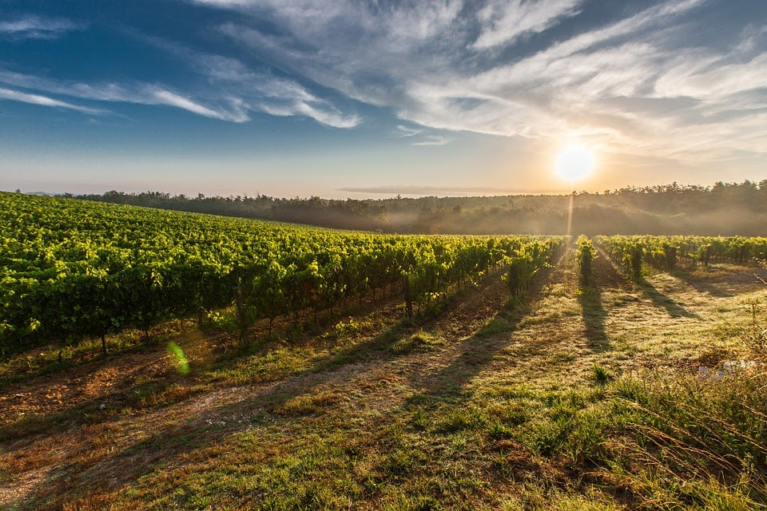
The Gospel John 6 v 27-35
Do not work for the food that perishes, but for the food that endures for eternal life, which the Son of Man will give you. For it is on him that God the Father has set his seal.’ Then they said to him, ‘What must we do to perform the works of God?’ Jesus answered them, ‘This is the work of God, that you believe in him whom he has sent.’ So they said to him, ‘What sign are you going to give us then, so that we may see it and believe you? What work are you performing? Our ancestors ate the manna in the wilderness; as it is written, “He gave them bread from heaven to eat.” ’ Then Jesus said to them, ‘Very truly, I tell you, it was not Moses who gave you the bread from heaven, but it is my Father who gives you the true bread from heaven. For the bread of God is that which comes down from heaven and gives life to the world.’ They said to him, ‘Sir, give us this bread always.’
Jesus said to them, ‘I am the bread of life. Whoever comes to me will never be hungry, and whoever believes in me will never be thirsty.
Reflection from the Rector:

Harvest Festivals are important and not only here in the countryside as they focus everyone’s minds on the provider and those who make Harvest possible. My mind goes back to a visit I once made to the great Tithe Barn at Breedon in Gloucestershire. It is typical of its type-its vast and cavernous-its majestic and so cathedral like- in medieval times and since it’s a fortitude against marauding raiders in search of food stuffs-there’s an air of permanence about it-its grand yet functional. We were the only visitors so to test the acoustic we sang a couple of verses of The Churches one Foundation-well you might if you’re clergy! We looked at the earthen floor and tried to imagine the many who had trodden there before us, also the kind of produce that would be stored in the barn that the fruits of their labours would be protected. Tithe Barns are a part of our national heritage and they speak powerfully of the people who lived around them. Harvest is about gathering in in the same way as into a barn it’s about bringing together and it’s also about giving thanks.

And so we give thanks. It’s all rather different this year but we are still gathering in Gods House and saying thank you to Him and to those who provide for us throughout the year. I have memories of Harvest right across the years to being a choirboy of 8 years old who was allowed an apple, an orange and another piece of fruit as a thank you at the end of Harvest Evensong. Happy Days. I am sure that you all have long memories of these festivals and in happier days with a church full of people. Let us pray that next year we may be able to have our usual larger congregations and lunches and suppers afterwards again. Just the other day whilst eating my evening meal I tried to sort out in my mind where each of the things on the table came from. It was on interesting exercise. After working it out a words of thanks was given in my heart-a word of gratitude firstly that I have food to eat, clothes to wear and a home to live in and that I know what it is to be warm, protected and safe. Many do not as we know.
What of Harvest Festivals then. Not just a trip down memory lane. Harvest is about today and tomorrow. It would be impertinent of me to try to talk of farming to famers and so I dismiss the thought rather I remind us of 4 things
God as Creator.” In the beginning” we read in verse one of chapter one of the first book in the bible. In the beginning GOD. Part of Harvest for me is recognising Creator God and that he is the source of life.
Humankind as Stewards remembering that its up to us as to whether the planet thrives or suffers, depending on how we use or misuse it.
Saying Thank you is also at the heart of this Festival and I am His provision for us recalling the words of the mediaeval mystic, Meister Eckhart who once said, ‘If the only prayer you ever say in your entire life is ‘thank you’, it will be enough’. I go to The Book of Common Prayer which I love and to the General Thanksgiving and those matchless words of gratitude to God.
“Almighty God, Father of all mercies, we thine unworthy servants do give thee most humble and hearty thanks for all thy goodness and loving-kindness to us and to all men. We bless thee for our creation, preservation, and all the blessings of this life; but above all for thine inestimable love in the redemption of the world by our Lord Jesus Christ, for the means of grace, and for the hope of glory. And, we beseech thee, give us that due sense of all thy mercies, that our hearts may be unfeignedly thankful; and that we show forth thy praise, not only with our lips, but in our lives, by giving up ourselves to thy service, and by walking before thee in holiness and righteousness all our days; through Jesus Christ our Lord, to whom, with thee and the Holy Spirit, be all honour and glory, world without end. Amen.”
At this Harvest Festival time which sadly is so different we bring our world that is groaning and suffering in travail of Coronavirus to the God in whom we live and move and have our being trusting Him for His provision for us and so there is one more point and that is that as we say thank you for earthly sustenance so we should for heavenly and so the Holy Communion Service when we are fed in a way that nourishes for spiritually. His body broken and blood shed for you and for me. As we give thanks so let us rejoice in His presence with us and move forward enlivened with his life today and always. Amen.
With greetings to you all from

The Rector and Revd Helen

Common Worship: Services and Prayers for the Church of England, material from which is included here, is copyright © The Archbishops' Council 2000 and published by Church House Publishing. Bible readings are taken from the New Revised Standard Version

