The Benefice of Malpas & Threapwood & Bickerton
Sunday next before Advent
CHRIST THE KING
Sunday 22nd November 2020
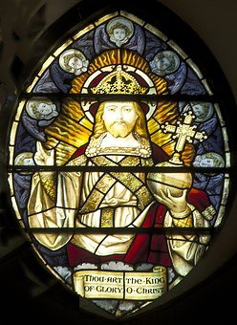
The Collect
Eternal Father,
whose Son Jesus Christ ascended to the throne of heaven
that he might rule over all things as Lord and King:
keep the Church in the unity of the Spirit
and in the bond of peace,
and bring the whole created order to worship at his feet;
who is alive and reigns with you,
in the unity of the Holy Spirit,
one God, now and for ever. Amen

Epistle: Ephesians 1: 15-end
I have heard of your faith in the Lord Jesus and your love towards all the saints, and for this reason ¹⁶I do not cease to give thanks for you as I remember you in my prayers. ¹⁷I pray that the God of our Lord Jesus Christ, the Father of glory, may give you a spirit of wisdom and revelation as you come to know him, ¹⁸so that, with the eyes of your heart enlightened, you may know what is the hope to which he has called you, what are the riches of his glorious inheritance among the saints, ¹⁹and what is the immeasurable greatness of his power for us who believe, according to the working of his great power. ²⁰God put this power to work in Christ when he raised him from the dead and seated him at his right hand in the heavenly places, ²¹far above all rule and authority and power and dominion, and above every name that is named, not only in this age but also in the age to come. ²²And he has put all things under his feet and has made him the head over all things for the church, ²³which is his body, the fullness of him who fills all in all.
Gospel reading: Matthew 25: 31-end
When the Son of Man comes in his glory, and all the angels with him, then he will sit on the throne of his glory. ³²All the nations will be gathered before him, and he will separate people one from another as a shepherd separates the sheep from the goats, ³³and he will put the sheep at his right hand and the goats at the left. ³⁴Then the king will say to those at his right hand, “Come, you that are blessed by my Father, inherit the kingdom prepared for you from the foundation of the world; ³⁵for I was hungry and you gave me food, I was thirsty and you gave me something to drink, I was a stranger and you welcomed me, ³⁶I was naked and you gave me clothing, I was sick and you took care of me, I was in prison and you visited me.” ³⁷Then the righteous will answer him, “Lord, when was it that we saw you hungry and gave you food, or thirsty and gave you something to drink? ³⁸And when was it that we saw you a stranger and welcomed you, or naked and gave you clothing? ³⁹And when was it that we saw you sick or in prison and visited you?” ⁴⁰And the king will answer them, “Truly I tell you, just as you did it to one of the least of these who are members of my family, you did it to me.” ⁴¹Then he will say to those at his left hand, “You that are accursed, depart from me into the eternal fire prepared for the devil and his angels; ⁴²for I was hungry and you gave me no food, I was thirsty and you gave me nothing to drink, ⁴³I was a stranger and you did not welcome me, naked and you did not give me clothing, sick and in prison and you did not visit me.” ⁴⁴Then they also will answer, “Lord, when was it that we saw you hungry or thirsty or a stranger or naked or sick or in prison, and did not take care of you?” ⁴⁵Then he will answer them, “Truly I tell you, just as you did not do it to one of the least of these, you did not do it to me.” ⁴⁶And these will go away into eternal punishment, but the righteous into eternal life.’

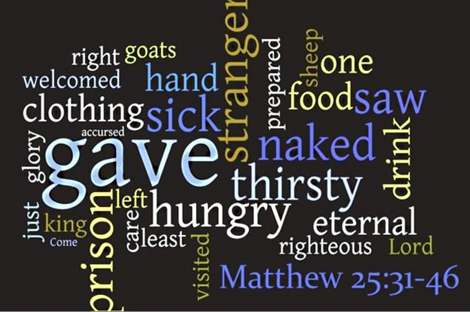

Reflection from the Rector:
Advent is upon us and next Sunday the stirring words , O Come, O Come Emanuel come to mind and will ring in my ears throughout the season as we prepare to hear once again the message of the angels that never ceases to thrill and inspire year by year. One of the collects has it “ Stir up O Lord the wills of your faithful people” . A prayer that we be stirred into action of body mind and spirit that we may indeed be ready to welcome Jesus into our hearts afresh as we celebrate His birth. So many do not even know of him, let alone know him as their Lord and Saviour and our task is to take the message out to all we meet. Stir up Sunday is about our own personal walk with Our Lord and so Advent can be used as a time of spiritual preparation and examination as we prepare for Christmas but it is also about the mission and outreach that is done in our daily living.

The model is that of Christ The King and the other Collect that we begin this weeks handout with centres on Christ the King. The kings public ministry was one of preaching and teaching-of getting alongside people- of healing the broken in body mind and spirit and bringing hope where there was only despair and apathy-offering a freedom that people could liberated to be the people that God intends them to be.

The king would be used and spent in this service but his roots would be firmly in prayer, quiet, study and reflection that he might minister evermore effectively. Advent can be a time when we can each double our prayer times and wait on Him who was born for each one of us.

The years of ministry led towards Jerusalem and so in a final glimpse of the King and The Kingdom Jesus rode into Jerusalem on a donkey and the crowds welcomed him and loved Him and especially those who had been at the receiving end of the 3 years of ministry and had experienced for themselves the healing touch. Jesus had stooped to touch those who others might not have given time too.. This work was not to be that of Jesus's alone and so in his own ministry he prepared the 12 to carry on his work after his own earthly ministry was over and so as a final part of that preparation Jesus knelt to wash the feet of those he had worked alongside and in doing so set all followers of all time the pattern of service. Peter objected in his hot headed way and then said well my hands and my head as well. We are those present day disciples and so we share the vital ministry of care that he gave such a powerful example of.

Jesus would suffer and he would die before he could experience the glory of Easter Day. Jesus chose the way to life in all its fullness because this represented the real nature of God he had come to reveal to mankind. The prophet Isaiah had written many centuries before the birth of Jesus of a suffering Servant. Jesus may well have identified himself with this strange powerless, tortured and abused figure who through his suffering and powerlessness shows us where true power lies. Jesus was willing to suffer and God raised Him up to be King above all Kings. Jesus's weakest point namely on the Cross became his moment of greatest power.

The reign of the King is extended every time, we his agents are signs of His love to others as we minister in His name.

May we then be stirred up and energised afresh and continue to help usher in the Golden Age of the Kingdom of The Servant King.

With greetings to you all from The Rector and Revd Helen

Common Worship: Services and Prayers for the Church of England, material from which is included here, is copyright © The Archbishops' Council 2000 and published by Church House Publishing. Bible readings are taken from the New Revised Standard Version.

