The Benefice of Malpas & Threapwood & Bickerton
The Third Sunday of Lent
Sunday 7th March 2021

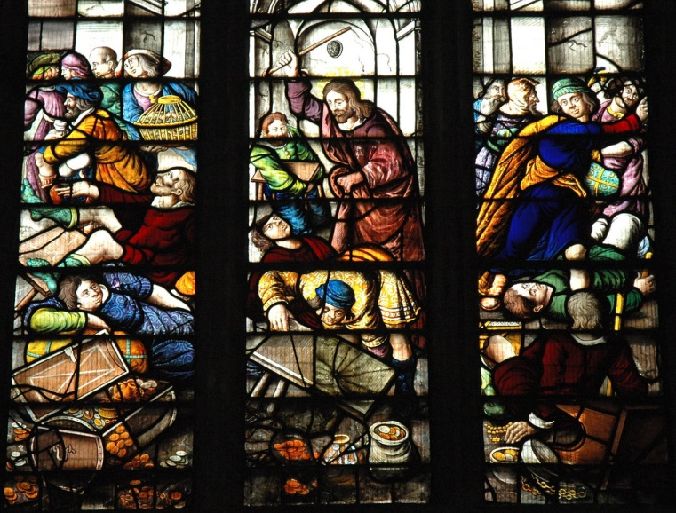

The Collect
Almighty God,
whose most dear Son went not up to joy but first he suffered pain,
and entered not into glory before he was crucified:
mercifully grant that we, walking in the way of the cross,
may find it none other than the way of life and peace;
through Jesus Christ your Son our Lord,
who is alive and reigns with you,
in the unity of the Holy Spirit,
one God, now and for ever. Amen

Epistle: 1 Corinthians 1:18-25
For the message about the cross is foolishness to those who are perishing, but to us who are being saved it is the power of God. ¹⁹For it is written,
‘I will destroy the wisdom of the wise,
and the discernment of the discerning I will thwart.’
²⁰Where is the one who is wise? Where is the scribe? Where is the debater of this age? Has not God made foolish the wisdom of the world? ²¹For since, in the wisdom of God, the world did not know God through wisdom, God decided, through the foolishness of our proclamation, to save those who believe. ²²For Jews demand signs and Greeks desire wisdom, ²³but we proclaim Christ crucified, a stumbling-block to Jews and foolishness to Gentiles, ²⁴but to those who are the called, both Jews and Greeks, Christ the power of God and the wisdom of God. ²⁵For God’s foolishness is wiser than human wisdom, and God’s weakness is stronger than human strength.

Gospel reading: John 2:13-22
Jesus Cleanses the Temple
13 The Passover of the Jews was near, and Jesus went up to Jerusalem. ¹⁴In the temple he found people selling cattle, sheep, and doves, and the money-changers seated at their tables. ¹⁵Making a whip of cords, he drove all of them out of the temple, both the sheep and the cattle. He also poured out the coins of the money-changers and overturned their tables. ¹⁶He told those who were selling the doves, ‘Take these things out of here! Stop making my Father’s house a market-place!’ ¹⁷His disciples remembered that it was written, ‘Zeal for your house will consume me.’ ¹⁸The Jews then said to him, ‘What sign can you show us for doing this?’ ¹⁹Jesus answered them, ‘Destroy this temple, and in three days I will raise it up.’ ²⁰The Jews then said, ‘This temple has been under construction for forty-six years, and will you raise it up in three days?’ ²¹But he was speaking of the temple of his body. ²²After he was raised from the dead, his disciples remembered that he had said this; and they believed the scripture and the word that Jesus had spoken.

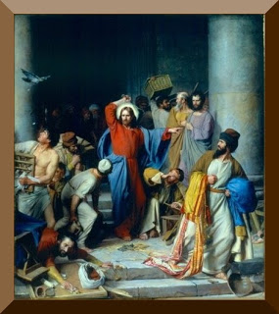

Reflection from the Rector
The Epistle reading is amongst my favourites and draws attention to the Cross of Christ that stands at the heart of our faith. It is the sign of the Cross that is made on our foreheads when we are baptised and it is in this sign that we conquer in our journeying in this world and given as we go on our journey to the heaven prepared for us. One of the greatest privileges of ministry is to be able to baptise and each service is very different because everyone is a unique and dearly loved child of a loving heavenly Father.

It would indeed seem to be a foolish sign to some as it would seem to be a sign of defeat but to us it is the sign of victory. It is this sign that we proclaim and none other.

This passage is for me is both a reminder and a challenge that the Cross has central place in all our worship together in church and that each of us bear the hallmarks of the cross in the way that we live out our daily lives that others too might be drawn to the life giving power of the Cross and so too know of its victory.

Jesus faced His bitterest moment which was on the Cross trusting His Father’s overarching love for Him, even in the darkest moment. We too can have that same trust, and as Jesus, will find that we are not let down. The Cross, that symbol of earthly cruelty became the standard of victory in the face of what would otherwise be claimed as earthly defeat. St Oswald, King and Martyr, was to set up this same standard in his kingdom of Northumbria long ago. He conquered in that sign. We too can today I believe as we draw strength from Jesus’s self-giving 2000 years ago.

With greetings to you all from The Rector and Revd Helen
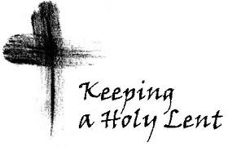
Common Worship: Services and Prayers for the Church of England, material from which is included here, is copyright © The Archbishops' Council 2000 and published by Church House Publishing. Bible readings are taken from the New Revised Standard Version.

